Dispatcher Persona

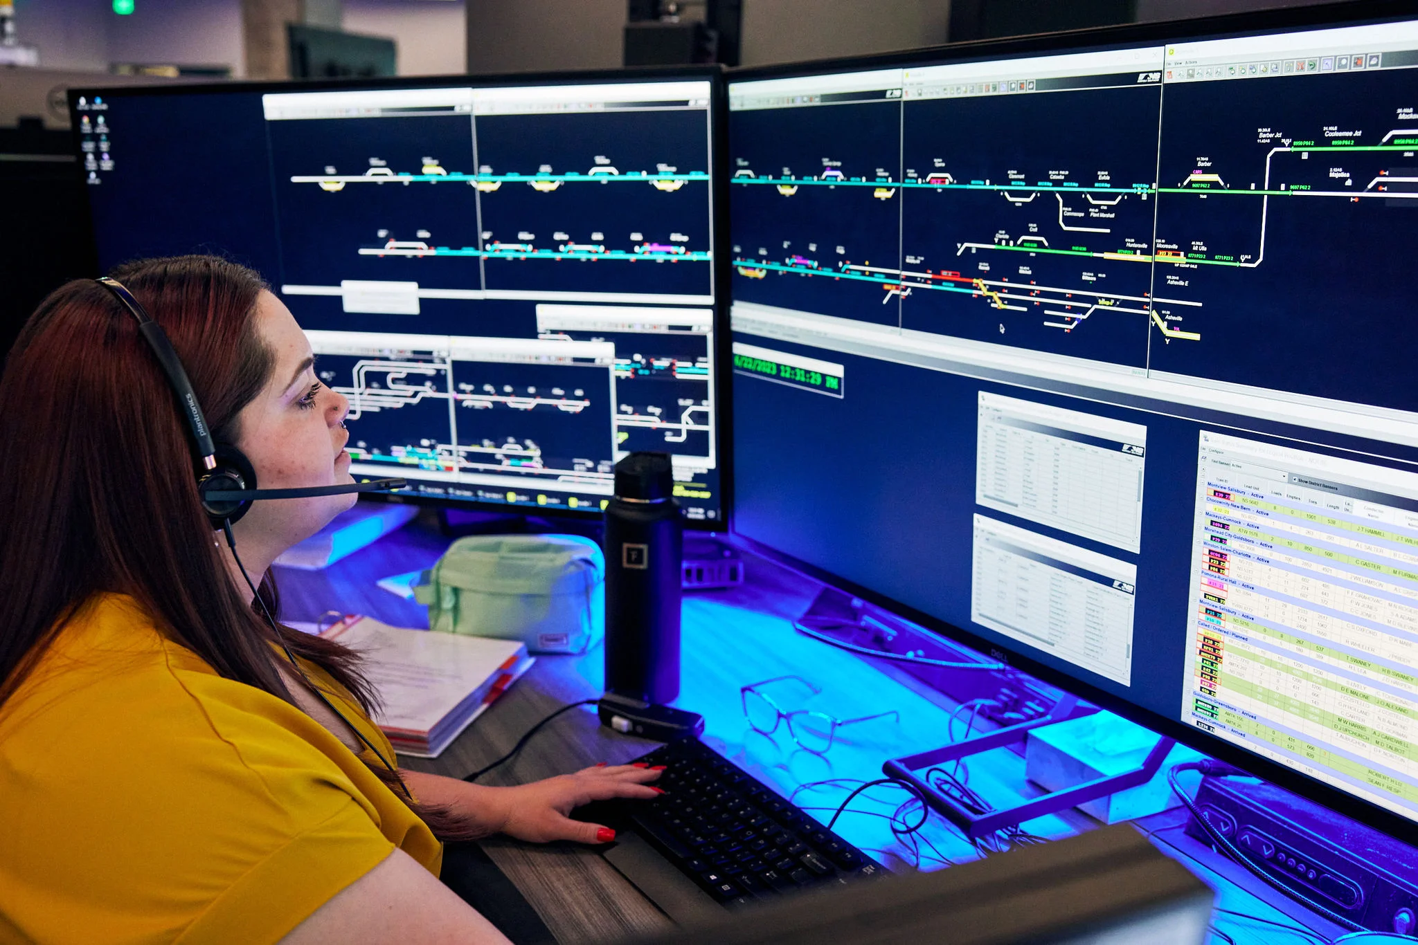

**Name:** Susan Johnson

**Age:**  44

**Residence:** Pittsburgh, PA

**Occupation:** Train Dispatcher

**Biography(small description of user) :** Susan is a seasoned train dispatcher with a wealth of experience. Her journey in this field began after completing her Bachelor's degree. She plays a crucial role in coordinating and managing train schedules to ensure smooth operations. Susan is known for her sharp organizational skills and ability to handle the complexities of coordinating train movements efficiently.

**Education Level:** Bachelor’s Degree in Business

**Salary Range:** $66,481 - $89,623

**Online Activities:** Susan is likely to engage in various online activities related to her job. This may include using specialized software for train dispatching, communicating with train drivers and other staff, and staying updated on industry news and developments.

**Technical Comfort Level:** Susan is adept at working with computers, a necessary skill for her role as a train dispatcher. Her technical proficiency allows her to navigate the software and systems crucial for managing train schedules and ensuring the safety and efficiency of train operations.

**Motivation to use Product:** Susan's motivation for using specific products lies in optimizing operational efficiency and ensuring the safety of train dispatching. She seeks tools that streamline communication, provide real-time data, and integrate seamlessly with existing systems, all while offering user-friendly interfaces.

**Hobbies:** Susan’s hobbies are reading, hiking and gardening. She looks forward to doing the wordle, mini crossword and the NYT Connections everyday.

**Goals:** Susan always wants to stay prepared for any emergency that comes her way. She also hopes to advance to be a dispatcher on a bigger train system.

**Resources :**

Demographics - <https://www.zippia.com/train-dispatcher-jobs/demographics/>